**Special Topics: Text Data Mining**

**MASY1-GC 5000**| **101** | Spring 2023 | **1/24/2023 - 5/2/2023 / Tuesdays**| 3 Credits

**In-person**

Course Site URL: <https://brightspace.nyu.edu/d2l/home/241735>

**General Course Information**

Name/Title: Dr. Andres Fortino, Clinical Associate Professor, He/Him/His

NYU Email: agf249@nyu.edu

Class Meeting Schedule: **1/24/2023 - 5/2/2023 / Tuesdays| 02:00pm -- 04:35pm**

Class Location: MT: Midtown Center, Bldg: MIDC Room:528

Office Hours: By appointment, NYU Zoom.

**Description**

This seminar will enhance the curriculum by identifying, analyzing, and applying special topics pertinent to the Management and Systems degree. The specific titles and content of each seminar will change to reflect emerging areas of interest, which can only be determined at the time of offering. The course may be used to satisfy the elective degree requirement. Applicability to specific concentrations will be noted in the course schedule and is at the department’s discretion.

This course will cover the primary techniques for data mining and analyzing text data to discover interesting patterns, extract practical knowledge, and support decision-making, emphasizing statistical approaches that can be generally applied to arbitrary text data in any natural language with no or minimum human effort. Detailed analysis of text data requires understanding natural language text, which is a difficult task for computers. However, several statistical approaches have been shown to work well for the "shallow" but robust analysis of text data for pattern finding and knowledge discovery. You will learn the basic concepts, principles, and major algorithms in text mining and their potential applications. We shall learn to perform keyword analysis, semantic analysis, create visual representations of the text, perform qualitative data analysis, similarity scoring of texts, entity and topic extraction, and latent semantic analysis of text data. We shall use Python as our primary analysis tool via the open-source visual programming interface Orange 3.

**Prerequisites**

1210 – Quantitative Models for Decision Makers

1240 – Information Technology and Data Analytics

**Learning Outcomes**

At the conclusion of this course, students will be able to:

* Construct applications using unstructured data like news articles and tweets.
* Perform sentiment analysis of customer feedback.
* Apply machine learning classifiers to categorize documents by content and author.
* Use document similarity scoring and topic models to sort large text data sets.
* Visualize and interpret text analytics, including statistical significance testing.
* Perform sentiment analysis of product reviews and social media postings.
* Use Python for text analysis via visual programming.
* Use chatbots to reinforce knowledge acquisition.

**Communication Methods**

This course describes a range of business opportunities and solutions using text. It also identifies sources of competitive intelligence in text and provides solutions for parsing and storing incoming knowledge. It is based on the merging technology of natural language processing. It uses real-world case studies, and the course provides examples of the most useful statistical and machine-learning techniques for handling text, semantic, and social data. We then describe how and what you can infer from the data and discuss practical approaches for visualizing and communicating the results to decision-makers.

This course will use the NYU Brightspace LMS to deliver course materials and communications.

Important course information, announcements, updates, course presentations and other materials will be posted on the NYU Brightspace LMS. The NYU Brightspace LMS will simultaneously forward course announcements to students' NYU email addresses.

Students are expected and required to be aware of any such announcements or communications and are advised to check the announcements and their NYU email address regularly during the 14-week duration of the course and afterward.

Credit students must use their NYU email to communicate. NYU Brightspace LMS course mail supports student privacy and FERPA guidelines.

The instructor’s email address is agf249@nyu.edu, and it is checked regularly and frequently; students will usually receive a reply within 12 hours during the workweek. The instructor does not have access to an NYU telephone number.

The instructor will conduct office hours using Zoom, by telephone, or in-person at the NYU campus—by appointment. If you would like to schedule a meeting, please email the instructor at least two days before the date you would like to meet. You should also suggest an alternative date if the first date is unavailable. Discussions through online platforms will require that you have speakers and a microphone. A video camera is highly recommended.

**Structure | Method | Modality**

This course will be conducted in person once a week on Tuesdays for 14 weeks. The class will encompass lectures, assignments, class team workshop exercises, examples and demos, a final exam, and a team project. All class content and assignments will be made available online via Brightspace. The student should check the class website daily for any updates or announcements.

**Expectations**

Learning Environment

You are essential in creating and sustaining an intellectually rigorous and inclusive classroom culture. Respectful engagement, diverse thinking, and our lived experiences are central to this course and enrich our learning community. As graduate students, you are expected to conduct yourselves professionally and engage and collaborate with your classmates. SPS classrooms are diverse and include students who range in age, culture, learning styles, and levels of professional experience. To maintain an inclusive environment that ensures all students can equally participate with and learn from each other and receive feedback and instruction from faculty during group discussions in the classroom, all course-based discussions and group projects should occur in a language that is shared among all participants.

Participation

To receive full credit for class participation, you should attend all classes since much of the learning occurs during class lectures, presentations, and discussions. You must contribute and engage in class dialogue during every class session for the course. Please get in touch with the instructor if you anticipate missing any part of the class. Please arrive on time so as not to disturb the lecture flow. Excessive lateness may result in a lower overall grade. Please get in touch with the instructor if you anticipate missing any part of the class.

Participation grades will be based on the following:

A. Involvement in class discussions, dialogues, and activities during each session

B. Participation demonstrates the integration of reading, classwork, relevance, and application.

C. Willingness to learn by accepting feedback, trying new skills and approaches, etc.

D. Quality/quantity of providing effective and balanced feedback.

Students who join the course during add/drop are responsible for identifying what assignments and preparatory work they have missed and completing and submitting those per the syllabus.

The Use of AI

You are expected to use AI (ChatGPT and code generation tools) appropriately in this class. In fact, some assignments will require it. Learning to use Al is an emerging skill, and I provide tutorials on how to use them. I am happy to meet and help with these tools during office hours or after class.

Be aware of the limits of ChatGPT:

* If you provide minimum effort prompts, you will get low-quality results. You will need to refine your prompts in order to get good outcomes. This will take work.
* Don't trust anything it says. If it gives you a number or fact, assume it is wrong unless you either know the answer or can check in with another source. You will be responsible for any errors or omissions provided by the tool. It works best for topics you understand.
* AI is a tool, but one that you need to acknowledge using. *Please include a paragraph at the end of any assignment that uses AI explaining what you used the Al for and what prompts you used to get the results. Please do so in compliance with academic honesty policies.*
* Be thoughtful about when this tool is useful. Only use it if it is appropriate for the case or circumstance.

Assignments and Deadlines

Students are expected to participate in each class session by understanding the subject, sharing ideas, or discussing/commenting on other students' comments. In addition, students must complete and submit all assigned homework on time. Late homework submission will result in a 25% loss of credit for one-week lateness and a 50% loss for no submission by the last day of class. Students are also expected to develop and present a team project with other students and take and pass a final exam.

See full detail of expectations under “Assessment Strategy” below. Further information about specific assignments can also be found in the “Course Outline” section.

Course Technology Use

We will utilize multiple technologies to achieve the course goals. I expect you to use technology to enhance the learning environment for all students. All class sessions require the use of Zoom.All class sessions require using technology (e.g., laptop, specialized computer applications) for learning purposes. You must bring a laptop to class.

**IT Service Desk**

(212)-998-3333

24 hours a day, seven days a week

Email: [AskIT@nyu.edu](mailto:AskIT@nyu.edu)

**Zoom Support**

* [NYU Zoom Guide for Students](https://nyu.service-now.com/servicelink/search_results.do?sysparm_document_key=kb_knowledge,bd4d4732dbf34f008fd2a2364b961964&sysparm_search=zoom)
* Make sure you are using [NYU Zoom](https://www.nyu.edu/life/information-technology/communication-and-conferencing/meetings-chat-conferencing/nyu-zoom.html) to log in to class
* Check the [NYU Zoom site](https://t.e2ma.net/click/pvdgzd/148ffmn/lccv1i) often for updates. (To update Zoom, you can also open it from your desktop and click the menu, then “Check for Updates.”)

**Brightspace Support**

* Log in to the [Brightspace](https://brightspace.nyu.edu/d2l/home)platform or visit the [Student Training](https://www.nyu.edu/life/information-technology/instructional-technology-support/instructional-technology-tools-and-services/nyu-lms-brightspace/student-training-lms-brightspace.html) website.
* Video on how to [Navigate the Bright Space Learning Environment](https://youtu.be/aYXbSBZ-VxI)

Feedback and Viewing Grades

I will provide timely, meaningful feedback on all your work via our course site in NYU Brightspace. You can access your grades on the course site Gradebook.

Attendance

expect you to attend all class sessions. Attendance will be taken into consideration when determining your final grade. Refer to the SPS Policies and Procedures page for additional attendance information.

Excused absences are granted in cases of documented serious illness, family emergency, religious observance, or civic obligation. In the case of religious observance or civic obligation, this should be reported in advance. Unexcused absences from sessions may hurt a student’s final grade. Students are responsible for assignments given during any absence.

Each unexcused absence or being late may result in a student’s grade being lowered by a fraction of a grade. A student who has three unexcused absences may earn a Fail grade.

Refer to the [SPS Policies and Procedures page](https://www.sps.nyu.edu/homepage/student-experience/policies-and-procedures.html) for additional attendance information.

**Textbooks And Course Materials**

**Required:**

Fortino, Andres, Text Data Mining- A Case Study Approach, Mercury Publishers, 2021

**Recommended:**

Miner, Gary, John Elder IV, Andrew Fast, Thomas Hill, Robert Nisbet, and Dursun Delen. Practical text mining and statistical analysis for non-structured text data applications. Academic Press, 2012.

**SOFTWARE**

**Required**

Voyant - <https://voyant-tools.org/>

Orange3 - <https://orangedatamining.com/>

Additional open-source programs will be required and installed as instructed in class.

**Grading | Assessment**

**Final Assignment** – (15%). There will be one final assignment as a team analytics deliverable to ensure that students have mastered the material presented. Instructions for the assignment are posted on the class website. The final assignment is due on the last day of the semester and will not be accepted late.

Final Team Case Study - (15%)

Part A – Proposal (5%)

Part B – Final Report (10%)

**Labs** – 10 required labs (50% total, 5% each). Two additional optional labs are provided for practice and additional topic coverage. There is a lab due every week. The top 10 of 12 lab grades will be retained to contribute to the final grade; the lowest two will be dropped. Student answers to the labs will be entered in the appropriate Assignment on the Brightspace class website. They are due one week after the class. There is a 25% penalty for a late assignment posting for up to a week, and only 50% credit will be given for a lab assignment delivered after that until the last day of class.

Lab 1 - Framing Questions (5%)

Lab 2 - Tools, Techniques and Data Preparation (5%)

Lab 3 - Term Frequency Analysis (5%)

Lab 4 - Keywords Analysis (5%)

Lab 5 - Sentiment Analysis (5%)

Lab 6 - Qualitative Data Analysis using Coding (5%)

Lab 7 - Visualizing Text Data (5%)

Lab 9 - Text Similarity Scoring (5%)

Lab 9 - Entity Extraction (5%)

Lab 10- Topic Recognition (5%)

Lab 11 - Computing with Words Using Fuzzy Logic (5%)

Lab 12 - Practice Final Exam (5%)

**Team Class Workshops (TCW)** – (15% total, 1.5% each). Ten required team workshop deliverables. An additional optional workshop on visual programming is provided for practice and additional topic coverage. There is a team workshop due every week. The top 10 out of 12 TCW grades will be retained to contribute to the final grade; the lowest team workshop grade will be dropped. Student answers to the team workshops will be entered in the appropriate Assignment on the Brightspace class website. They are due by the end of the next day. The team works on the assignments at the end of each class, so there is no need for extra time to complete assignments. No credit will be given for team class workshop assignments delivered after that.

TCW 1 - Text Data Mining Case Studies (1.5%)

TCW 2 - Framing Analytical Questions (1.5%)

TCW 3 - Tools, Techniques and Data Preparation (1.5%)

TCW 4 - Word Frequency Analysis (1.5%)

TCW 5 - Keywords Analysis (1.5%)

TCW 6 - Sentiment Analysis (1.5%)

TCW 7 - Visualizing Text Data (1.5%)

TCW 8 - Coding for Qualitative Data Analysis (1.5%)

TCW 9 - Text Similarity Scoring (1.5%)

TCW 10 - Entity Extraction (1.5%)

TCW 11 - Topic Recognition (1.5%)

TCW 12 - Computing with Words Using Fuzzy Logic (1.5%)

**Review Quizzes** - (10%). There are 10 out of 13 required REs (Reflection Exercises), 1% each for taking them; credit is not based on the score. This is not an exercise to measure what you know but to help you transfer knowledge from short-term memory to long-term memory. Students who use these exercises may improve their final exam grades by as much as 30%. The quizzes are open online for a whole week after the class meeting on that subject and are timed to maximize knowledge transfer. Students are advised to take each Quiz when it is available.

**Final Exam** (10%) - A 60-minute exam will be administered on week 14.

*See the* [*“Grades” section of Academic Policies*](https://www.sps.nyu.edu/homepage/student-experience/policies-and-procedures.html#Graduate1) *for the complete grading policy, including the letter grade conversion, and the criteria for an incomplete grade, taking a course on a pass/fail basis, and withdrawing from a course.*

**Course Outline**

Start/End Dates: **1/24/2023 - 5/2/2023 / Tuesdays**

Time: 02:00 pm04:35 pm

No Class Date(s): **Spring Break - Tuesday, March 14, 2023**

Special Notes:

**Session 1 - 01/24/23**

**Topic Description:** Introduction to Text Data Mining

What is text data mining?

**Assignments:** Read Fortino CH 1

**Session 2 – 01/31/23**

**Topic description** – Framing Analytical Questions

How to frame good analytical questions?

**Assignments:** Lab 1: Framing Questions

**Session 3 – 02/07/23**

**Topic description** – Preparing the data files

What are the tools, data formats and data preparation processes?

**Assignments**: Lab 2: Preparing data sets

**Session 4 – 02/14/23**

**Topic description –** Word Frequency Analysis

How do we discover the most frequent words in text data?

**Assignments:**  Lab 3: Word Frequency Analysis

**Session 5 – 02/21/23**

**Topic description –** Keyword Analysis

How do we discover the keywords that characterize a document?

**Assignments**: Lab 4: Keyword Analysis

**Session 6 – 02/28/23**

**Topic description –** Sentiment Analysis

How do we discover what people are telling us in their texts?

**Assignments:**  Lab 5: Sentiment Analysis

**Session 7 – 03/07/23**

**Topic description –** Coding Qualitative Data

How do we analyze qualitative data using coding techniques?

**Assignments:**  Lab 6: Coding Qualitative data

**Session 8 – 03/21/23**

**Topic description –** Visualizing Text Data

How do we convert our text analysis to a visual?

**Assignments:**  Lab 7: Visualizing Text

**Session 9 – 03/28/23**

**Topic description –** Text Similarity Scoring

How do we compare the similarities between the two text documents?

**Assignments:**  Lab 8: Text Similarity Scoring

**Session 10 – 04/04/23**

**Topic description –** Named Entity Recognition

How do we extract the entities from textual data?

**Assignments:** Lab 9: Entity Recognition

**Session 11 – 04/11/23**

Topic description – Topic Recognition

How do we extract the topics covered by a document?

**Assignments:** Lab 10: Topic Recognition

**Session 12 – 04/18/23**

**Topic description –** Fuzzy Logic for Text Data Mining

Introduction to Computing with Words (CCW) fuzzy logic techniques for text mining

**Assignments:**  Lab 11: Fuzzy Logic (optional)

**Session 13 – 04/25/23**

**Topic description –** Text Generation using Generative Pre-Training Transformers

Introduction to GPT for text data mining

**Assignments:** Lab 12 Final Exam Practice (optional)

**Session 14 – 05/02/23**

**Topic description –** Exam

FINAL EXAM – and FINAL ASSIGNMENT DUE

**Assignments:** Final Assignment

**NOTES:**

The syllabus may be modified to meet the needs of students better and to achieve the learning outcomes.

The School of Professional Studies (SPS) and its faculty celebrate and are committed to inclusion, diversity, belonging, equity, and accessibility (IDBEA), and seek to embody the IDBEA values. The School of Professional Studies (SPS), its faculty, staff, and students are committed to creating a mutually respectful and safe environment (*from the* [*SPS IDBEA Committee*](https://www.sps.nyu.edu/homepage/about-us/idbea/about-idbea.html)).

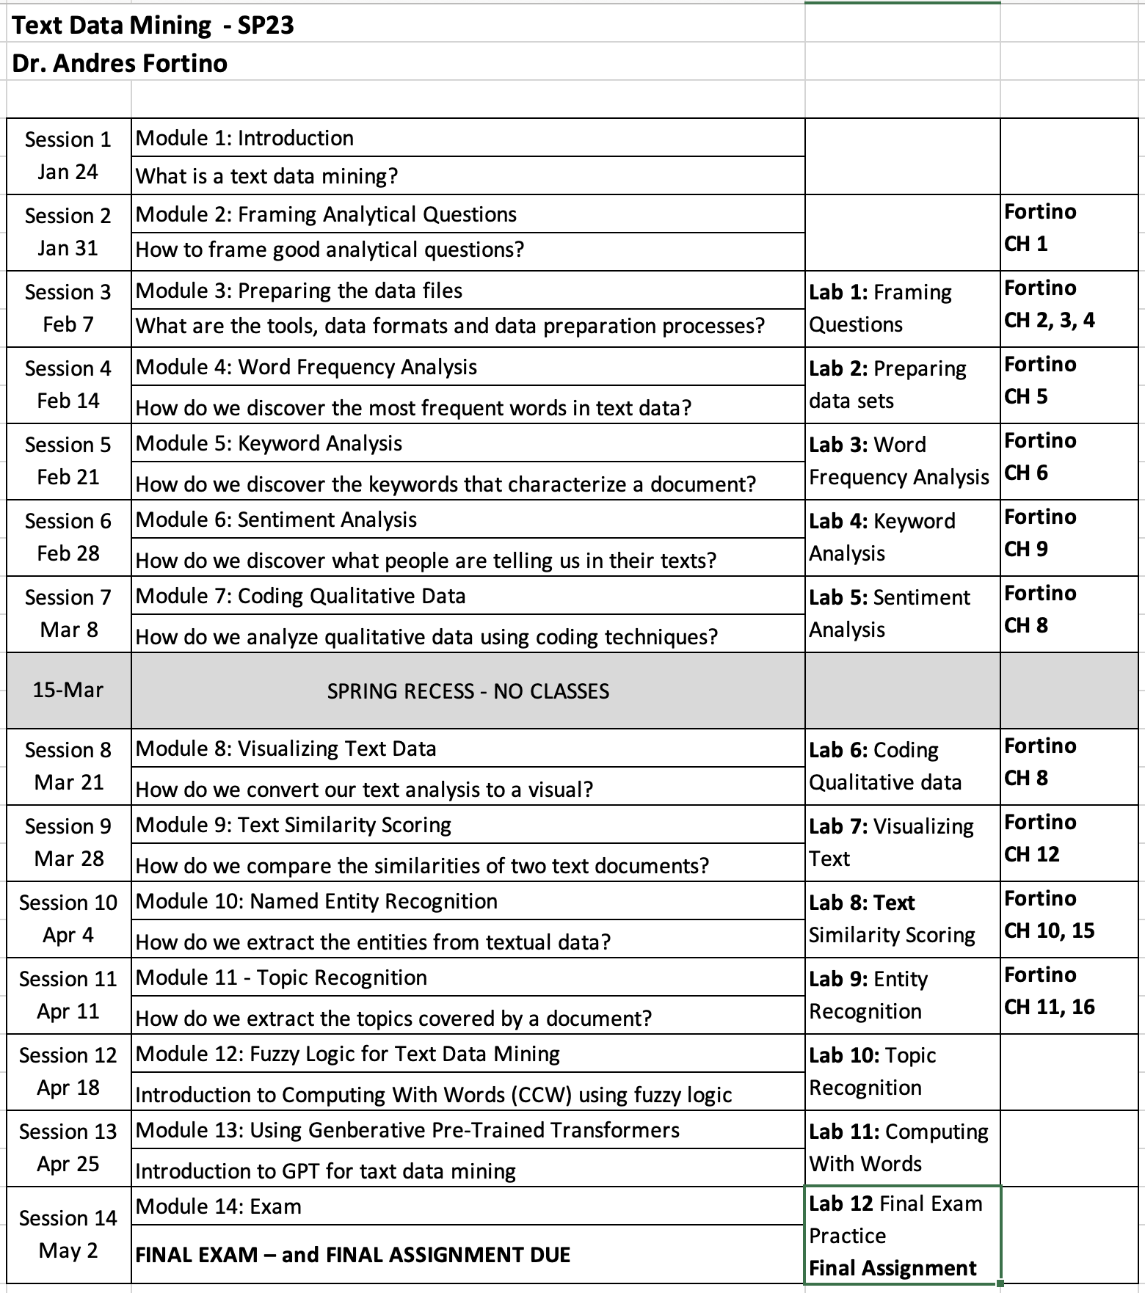

**New York University School of Professional Studies Policies**

1. Policies - You are responsible for reading, understanding, and complying with [University Policies and Guidelines](http://www.nyu.edu/about/policies-guidelines-compliance.html), [NYU SPS Policies and Procedures](http://sps.nyu.edu/academics/academic-policies-and-procedures.html), and [Student Affairs and Reporting](https://www.nyu.edu/about/policies-guidelines-compliance/policies-and-guidelines/student-services.html).

2. Learning/Academic Accommodations - New York University is committed to providing equal educational opportunity and participation for students who disclose their dis/ability to the [Moses Center for Student Accessibility](https://www.nyu.edu/students/communities-and-groups/student-accessibility.html). If you are interested in applying for academic accommodations, contact the [Moses Center](https://www.nyu.edu/students/communities-and-groups/student-accessibility/academic.html) early in the semester. If you already receive accommodations through the Moses Center, request your accommodation letters through the [Moses Center Portal](https://www.nyu.edu/students/communities-and-groups/student-accessibility.html) as soon as possible ([mosescsa@nyu.edu](mailto:mosescsa@nyu.edu) | 212-998-4980).

3. Health and Wellness - To access the University's extensive health and mental health resources, contact the [NYU Wellness Exchange](https://www.nyu.edu/students/health-and-wellness/wellness-exchange.html). You can call its private hotline (212-443-9999), available 24 hours a day, seven days a week, to reach out to a professional who can help to address day-to-day challenges as well as other health-related concerns.

4. Student Support Resources - There are a range of resources at SPS and NYU to support your learning and professional growth. For a complete list of resources and services available to SPS students, visit the [NYU SPS Office of Student Affairs site](https://www.sps.nyu.edu/homepage/student-experience/resources-and-services.html).

5. Religious Observance - As a nonsectarian, inclusive institution, NYU policy permits members of any religious group to absent themselves from classes without penalty when required for compliance with their religious obligations. Refer to the [University Calendar Policy on Religious Holidays](https://www.nyu.edu/about/policies-guidelines-compliance/policies-and-guidelines/university-calendar-policy-on-religious-holidays.html) for the complete policy.

6. Academic Integrity and Plagiarism - You are expected to be honest and ethical in all academic work. Moreover, you are expected to demonstrate how what you have learned incorporates an understanding of the research and expertise of scholars and other appropriate experts; and thus recognizing others' published work or teachings—whether that of authors, lecturers, or one's peers—is a required practice in all academic projects.

Plagiarism involves borrowing or using information from other sources without proper and full credit. You are subject to disciplinary actions for the following offenses which include but are not limited to cheating, plagiarism, forgery or unauthorized use of documents, and false form of identification

[Turnitin](https://www.nyu.edu/servicelink/KB0018471), an originality detection service in NYU Brightspace, may be used in this course to check your work for plagiarism.

Read more about academic integrity policies at the NYU School of Professional Studies on the [Academic Policies for NYU SPS Students](https://www.sps.nyu.edu/homepage/student-experience/policies-and-procedures.html) page.

7. Use of Third-Party Tools - During this class, you may be required to use non-NYU apps/platforms/software as a part of course studies, and thus, will be required to agree to the “Terms of Use” (TOU) associated with such apps/platforms/software.

These services may require you to create an account but you can use a pseudonym (which may not identify you to the public community, but which may still identify you by IP address to the company and companies with whom it shares data).

You should carefully read those terms of use regarding the impact on your privacy rights and intellectual property rights. If you have any questions regarding those terms of use or the impact on the class, you are encouraged to ask the instructor prior to the add/drop deadline.